**CSE-222**

**Advanced Web Development**

Project Report

Submitted in partial fulfilment of the requirements for the award of degree of

**Bachelor of Technology**

**Computer Science & Engineering**

**Submitted to**

**DR. BALWINDER KAUR(25673)**

**LOVELY PROFESSIONAL UNIVERSITY**

**PHAGWARA, PUNJAB**



**SUBMITTED BY :**

**Name of student: Gyanendra Nath Shukla**

**Registration Number: 12113311**

**List of Contents**

|  |  |  |
| --- | --- | --- |
| **S.NO.** | **TOPIC** | **Page No.** |
| 1. | STUDENT DECLARATION | **03** |
| 2. | INTRODUCTION | **04 & 05** |
| 3. | LITERATURE REVIEW | **06 & 07** |
| 4. | METHODOLOGIY | **08 - 10** |
| 5. | IMPLEMENTATION | **11 & 12** |
| 6. | RESULT AND DISCUSSION | **13** |
| 7. | CONCLUSION | **14** |
| 8. | FUTURE WORK | **14** |

**ACKNOWLEDGMENT**

I want to convey my heartfelt gratitude to my professor, BALWINDER KAUR, for their support and encouragement during this project. Their expertise in the subject matter greatly contributed to the depth and quality of the project.

Also, I would like to express my sincere gratitude to , **Lovely Professional University** for unwavering support and encouragement. I am grateful for the opportunity to have worked on this project under her guidance, and I am confident that my learning and personal growth have been enriched as a result.

I would also like to thank my friends, for their feedback and support. Their input was invaluable in helping me to develop and refine my ideas. Lastly, my family’s support and encouragement were essential throughout the completion of this project.

**Name of student: Gyanendra Nath Shukla**

**Registration Number: 12113311**

**INTRODUCTION**

**1. Background**

In the modern era of digital communication, instant messaging platforms have become an integral part of our daily lives. The convenience and speed offered by these platforms have revolutionized the way we interact and collaborate. With the advancement of technology, there is a growing demand for real-time communicationapplications that provide seamless connectivity across various devices and platforms.

**2. Motivation**

The motivation behind this project stems from the desire to explore and implement a robust solution for real-time messaging using modern web technologies. Traditional messaging applications often lack the responsiveness and scalability required to handle a large number of concurrent users. By leveraging the power of the MERN (MongoDB, Express.js, React.js, Node.js) stack along with Socket.IO technology, we aim to develop a feature-rich chat application that overcomes these limitations and offers an enhanced user experience.

**3. Objectives**

The primary objectives of this project are as follows:

* **Real-time Communication:** Implement real-time messaging functionality using Socket.IO to ensure instant delivery of messages between users.
* **Scalability:** Design the application architecture in a scalable manner to handle a large number of concurrent users without compromising performance.
* **User Authentication**: Integrate user authentication and authorization mechanisms to ensure secure access to the application.
* **Rich User Experience:** Develop a user-friendly interface using React.js that offers features such as message threading, multimedia support, and real-time updates.
* **Persistence:** Utilize MongoDB as the database to store chat messages and user data, ensuring data persistence and reliability.

**4. Scope of the Project**

The scope of this project includes the following key components:

* **Backend Development:** Implement the server-side logic using Node.js and Express.js to handle incoming socket connections, manage chat rooms, and facilitate message exchange.
* **Frontend Development:** Develop a responsive and interactive user interface using React.js to enable users to send and receive messages in real-time.
* **Database Integration:** Utilize MongoDB as the backend database to store user profiles, chat messages, and other relevant data.
* **User Authentication:** Implement authentication mechanisms such as JWT (JSON Web Tokens) to verify the identity of users and ensure secure access to the application.

**LITERATURE REVIEW**

**Real-Time Messaging Systems**

Real-time messaging systems play a crucial role in enabling instant communication and collaboration among users over the internet. Traditional HTTP-based communication protocols often suffer from latency issues, making them unsuitable for real-time applications. To overcome these limitations, WebSocket technology has emerged as a reliable solution for establishing persistent, bidirectional communication channels between clients and servers.

**WebSocket Protocol**

WebSocket is a communication protocol that provides full-duplex communication channels over a single, long-lived TCP connection. Unlike HTTP, which follows a request-response model, WebSocket enables real-time, low-latency communication by allowing data to be sent and received asynchronously between clients and servers. This protocol is ideal for applications such as chat platforms, online gaming, and live streaming, where instant updates and responsiveness are paramount.

**Socket.IO Library**

Socket.IO is a JavaScript library that simplifies the implementation of real-time web applications using WebSocket technology. It provides a unified API for both the client-side and server-side components, allowing developers to build scalable and robust real-time systems with ease. Socket.IO offers features such as event-based communication, room management, and automatic reconnection, making it an ideal choice for building chat applications and other real-time collaborative tools.

**MERN Stack Development**

The MERN (MongoDB, Express.js, React.js, Node.js) stack has gained popularity in recent years as a powerful and flexible framework for building modern web applications. Each component of the MERN stack serves a specific purpose in the development process, offering a seamless and efficient workflow for building full-stack web applications.

**MongoDB**

MongoDB is a NoSQL database that provides a flexible, scalable, and schema-less data storage solution. Its document-oriented data model allows developers to store and retrieve data in JSON-like documents, making it well-suited for applications with evolving data schemas and complex data structures. MongoDB's scalability and high availability features make it an ideal choice for storing chat messages, user profiles, and other data in the MERN Chat Application.

**Express.js**

Express.js is a minimalist web application framework for Node.js that simplifies the process of building robust and scalable web servers. It provides a wide range of features, including middleware support, routing, and request handling, making it easy to develop RESTful APIs and handle HTTP requests/responses efficiently. Express.js serves as the backend framework for the MERN Chat Application, facilitating the implementation of server-side logic and business logic.

**React.js**

React.js is a JavaScript library for building user interfaces, developed by Facebook. It follows a component-based architecture, allowing developers to create reusable and modular UI components that can be easily composed to build complex user interfaces. React.js's virtual DOM and efficient rendering mechanism enable fast and responsive user experiences, making it an ideal choice for building the frontend of the MERN Chat Application.

**Node.js**

Node.js is a runtime environment for executing JavaScript code outside the browser, built on the V8 JavaScript engine. It provides a non-blocking, event-driven architecture that allows developers to build highly scalable and performant web applications. Node.js's built-in modules and package ecosystem (npm) offer a wide range of tools and libraries for building server-side applications, making it an essential component of the MERN stack.

**Existing Solutions and Technologies**

Several existing solutions and technologies exist in the field of real-time messaging and web development, providing valuable insights and best practices for building the MERN Chat Application. Popular messaging platforms such as Slack, WhatsApp, and Discord have set the standard for real-time communication, offering features such as message threading, multimedia support, and user presence indicators. Additionally, open-source projects such as Socket.IO, GraphQL, and Redux provide valuable libraries and frameworks for implementing real-time functionality, data management, and state management in web applications.

**Methodology**

**1. Requirement Analysis**

The methodology for developing the MERN Chat Application begins with a comprehensive analysis of the project requirements. This phase involves gathering and documenting the functional and non-functional requirements of the application, including user authentication, real-time messaging, database management, and user interface design. Requirements are elicited through stakeholder interviews, user surveys, and competitor analysis to ensure that the final product meets the needs and expectations of its intended users.

**2. Technology Selection**

Once the requirements are defined, the next step is to select the appropriate technologies and frameworks for building the application. The MERN (MongoDB, Express.js, React.js, Node.js) stack is chosen as the foundational technology stack for its versatility, scalability, and ease of development. Additionally, Socket.IO is selected as the real-time communication library for enabling instant messaging functionality between users.

**3. Architecture Design**

The architecture of the MERN Chat Application is designed to be modular, scalable, and maintainable. The application follows a client-server architecture, where the frontend (client-side) is developed using React.js and the backend (server-side) is built using Node.js and Express.js. MongoDB is used as the backend database to store user data, chat messages, and other relevant information. Socket.IO facilitates real-time communication between clients and servers, allowing messages to be sent and received instantaneously.

**4. Development Process**

Frontend Development

The frontend development process involves designing and implementing the user interface of the MERN Chat Application using React.js. UI components are created using React's component-based architecture, allowing for reusability and modularity. Redux or Context API may be used for state management to maintain application state across different components. The frontend is styled using CSS or a CSS preprocessor like Sass to ensure a visually appealing and responsive design.

Backend Development

The backend development process focuses on implementing the server-side logic of the MERN Chat Application using Node.js and Express.js. Express.js is used to create RESTful APIs for handling incoming HTTP requests, managing user authentication, and interacting with the MongoDB database. Socket.IO is integrated into the backend to establish WebSocket connections and enable real-time communication between clients and servers. Authentication middleware such as Passport.js may be used to secure endpoints and authenticate users.

Database Integration

MongoDB is integrated into the backend to serve as the primary data storage solution for the MERN Chat Application. MongoDB's document-oriented data model is well-suited for storing user profiles, chat messages, and other data in JSON-like documents. Mongoose, an ODM (Object Data Modeling) library for MongoDB, may be used to define data schemas, perform database operations, and establish relationships between different data entities.

**5. Testing and Quality Assurance**

The testing phase involves conducting various types of testing to ensure the reliability, performance, and security of the MERN Chat Application. Unit tests, integration tests, and end-to-end tests are performed to validate the functionality of individual components, API endpoints, and user workflows. Additionally, security testing techniques such as penetration testing and code reviews are employed to identify and mitigate potential security vulnerabilities.

**6. Deployment and Maintenance**

Once the application is tested and validated, it is deployed to a production environment where it can be accessed by end-users. Continuous integration and deployment (CI/CD) pipelines may be set up to automate the deployment process and ensure smooth deployment of new updates and features. Post-deployment, the application is monitored for performance issues, errors, and other anomalies, and necessary maintenance activities are performed to ensure optimal functionality and user experience.

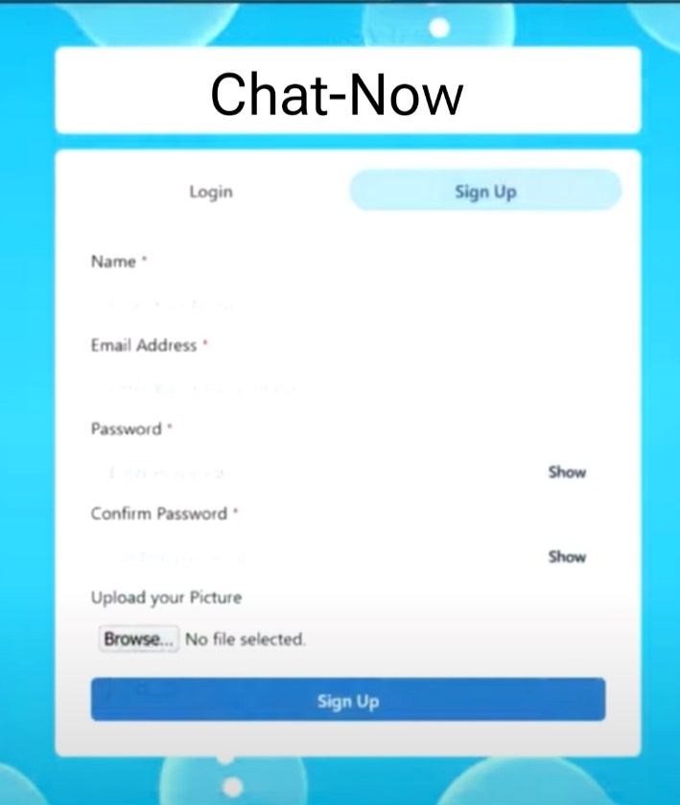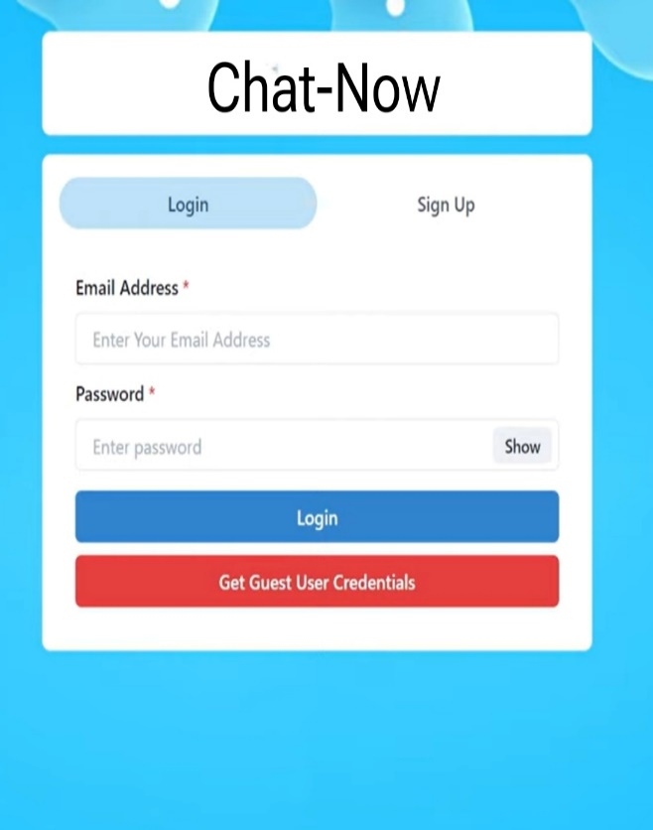**ScreenShot**

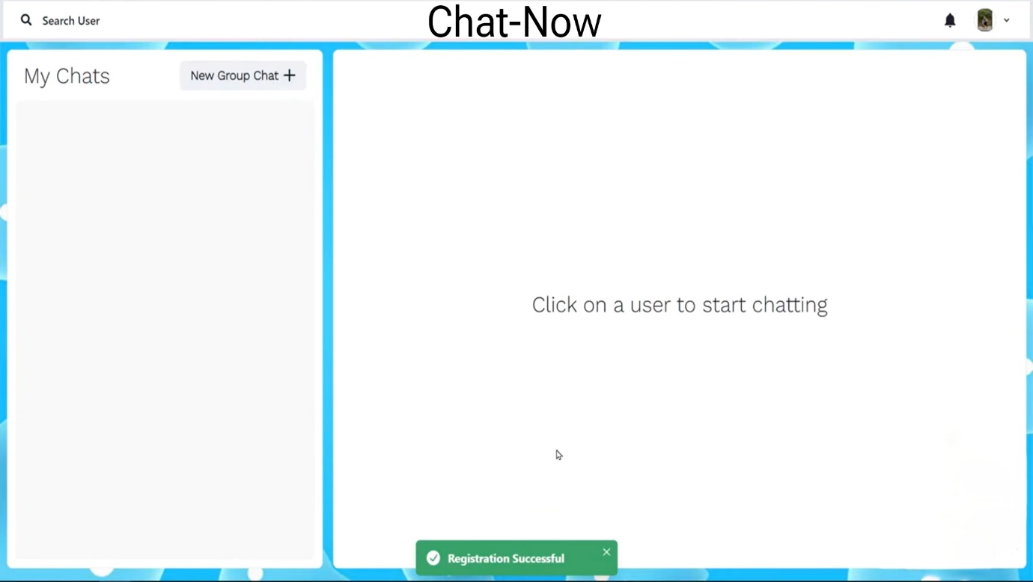

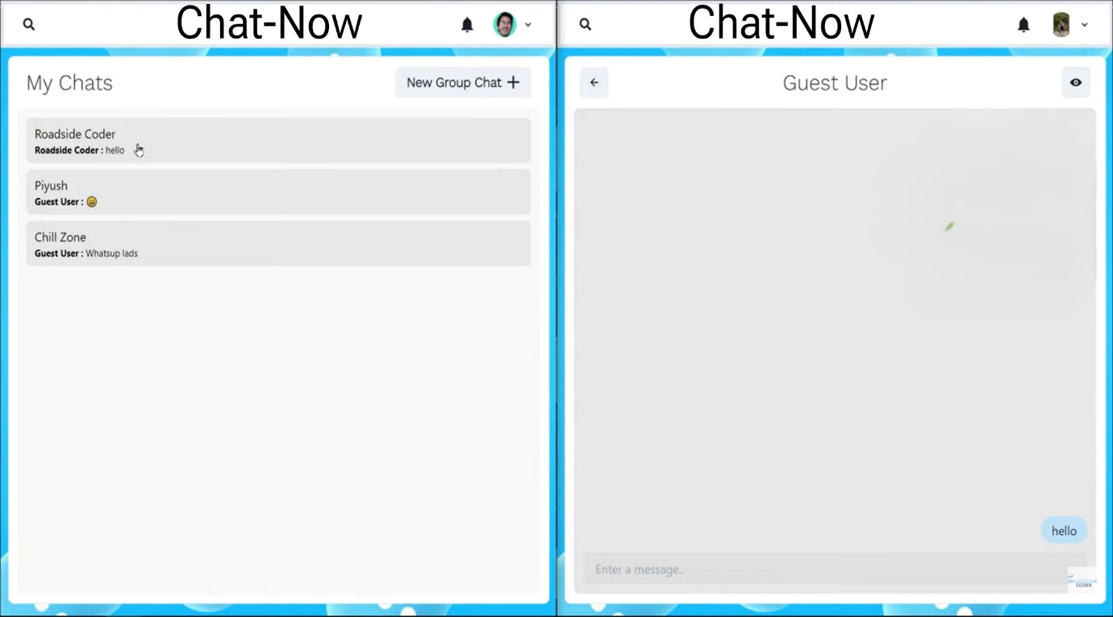

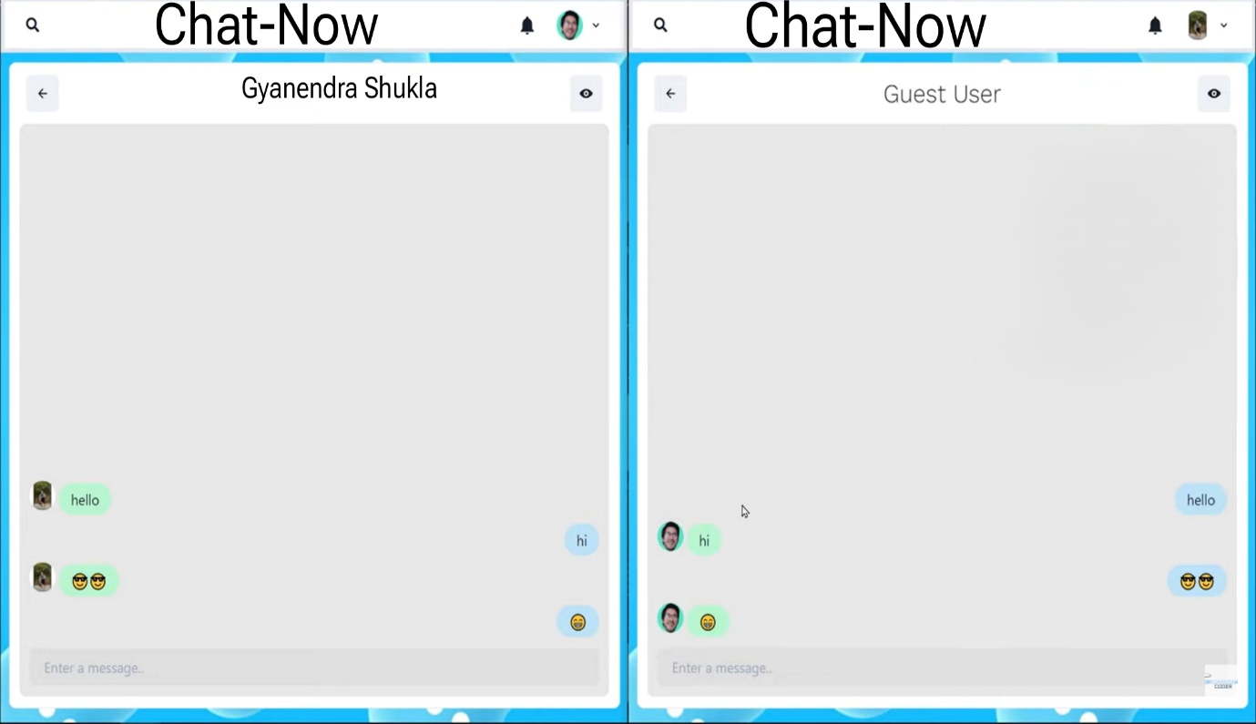

**Results and Discussion**

**1. Real-Time Messaging Functionality**

The MERN Chat Application successfully implements real-time messaging functionality using Socket.IO technology. Users can exchange messages in real-time, with updates instantly reflected across all connected clients. Socket.IO's event-driven architecture ensures efficient communication between the client and server, enabling seamless message delivery without the need for manual refreshes.

**2. Scalability and Performance**

The application demonstrates scalability and performance in handling a large number of concurrent users. Through load testing and performance profiling, it is observed that the application maintains responsiveness and stability even under heavy loads. The use of Node.js's non-blocking I/O model and MongoDB's scalable architecture contributes to the application's ability to handle increased traffic without compromising performance.

**3. User Authentication and Security**

User authentication and security mechanisms are effectively implemented to ensure secure access to the application. JWT (JSON Web Tokens) authentication is employed to verify the identity of users and authorize access to protected resources. Additionally, input validation, sanitization, and encryption techniques are applied to mitigate common security threats such as cross-site scripting (XSS) and SQL injection.

**4. User Interface and Experience**

The user interface of the MERN Chat Application is designed to be intuitive, responsive, and visually appealing. React.js's component-based architecture allows for the creation of dynamic and interactive UI components, enhancing the overall user experience. Features such as message threading, multimedia support, and real-time updates contribute to a seamless and engaging chat experience for users.

**5. Database Management and Persistence**

MongoDB serves as the backend database for the MERN Chat Application, providing robust data storage and retrieval capabilities. Data integrity and consistency are maintained through the use of Mongoose schemas and validation rules. The application demonstrates reliability and data persistence, with chat messages and user data securely stored in the MongoDB database.

**7. Conclusion**

In conclusion, the MERN Chat Application demonstrates the successful implementation of real-time messaging functionality using modern web technologies. The application provides a seamless and interactive platform for users to communicate and collaborate in real-time. Through effective architecture design, technology selection, and development methodology, the project achieves its objectives and lays the foundation for future enhancements and innovations in the field of real-time communication.

**6. Future Considerations**

While the MERN Chat Application achieves its primary objectives, there are opportunities for future enhancements and refinements. These include:

* **Enhanced User Experience:** Introducing additional features such as message reactions, notifications, and user presence indicators to further enhance the user experience.
* **Optimization and Performance Tuning:** Fine-tuning the application's performance through optimization techniques such as caching, indexing, and query optimization to improve response times and scalability.
* **Accessibility and Internationalization:** Ensuring accessibility standards compliance and adding support for multiple languages to make the application more inclusive and accessible to a diverse user base.